


Drupa 2024 - Landa Digital Printing and Gelato Announce Collaboration to Drive Innovation and Streamline Print Production
- Landa extends the availability of Nanographic print via Gelato global network
- Gelato’s production partners benefit from market-leading print quality and color, and on-demand short to medium-run jobs
Rehovot, Israel – May 30th, 2024 – Landa Digital Printing and Gelato, today announce a collaboration between both parties that redefines the possibilities of print. The partnership leverages Landa's Nanographic print technology and customer network, and Gelato's global software platform – GelatoConnect – for the delivery of on-demand, short-to-medium run, digitally printed jobs with unparalleled print quality.
Utilizing Gelato’s robust fulfillment network, present in more than 32 countries, digital print partners also benefit from streamlined workflows, enhanced market reach, and a shared commitment from both companies toward enhanced sustainability.
Gil Oron, CEO, Landa Digital Printing, comments: “We are delighted to partner with Gelato who have an excellent global business model with a product and machine agnostic software, GelatoConnect, that will drive volume and increase profitability in our customers’ production facilities thereby enabling us to broaden the use of Nanography® across the globe.”
“With more than 56 presses in the market within print businesses both large and small, Nanography is now a mature, robust, and future-proofing technology, driving production efficiency with high quality output thereby supporting creators around the world – our customers.”
Key Collaboration Benefits include:
- Speed of Production: For Gelato’s creators and global e-commerce customers, Landa’s speed of production allows the creator economy to launch successful sales campaigns and be able to deliver on time with high quality.

- Predictable and High Quality: Landa's Nanography offers stunning color reproduction, image fidelity, and the ability to print on diverse materials, expanding creative possibilities and ensuring brand consistency.

- Optimized Production & Global Reach: The combination of B1/41’’ efficient print processes and a worldwide fulfillment network allows for highly optimized, cost-effective production, and the flexibility to access quality printing from anywhere.

- Streamlined Customer Experience: Gelato's intuitive production platform and end-to-end software integrates seamlessly with Landa's technology, ensuring quick setup for programmatic work and a user-friendly ordering and production experience for print buyers.

- Sustainability Focus: Landa's water-based inks and commitment to resource efficiency resonate with Gelato's sustainable approach to production that’s based on local, on-demand, making this a win for eco-minded customers.

- Synergistic Vision: Landa and Gelato are united in their drive to transform the print landscape. This strategic partnership delivers exceptional results for print buyers, prioritizing quality, convenience, and a commitment to responsible production.
Gelato is a software company that enables a digital print on-demand facility to significantly improve end-to-end production efficiency. GelatoConnect allows a single print facility to compete effectively with the old traditional and legacy bound manufacturing facility with local, on-demand production on a global scale through the world’s largest network for production on demand.
Henrik Muller-Hansen, CEO and Founder of Gelato, comments: “Landa Presses are redefining the print and packaging landscape. Together, with Gelato, we can serve our print customers by empowering them with the right technology and software to optimize efficiency, quality, and profitability.”
[ENDS]
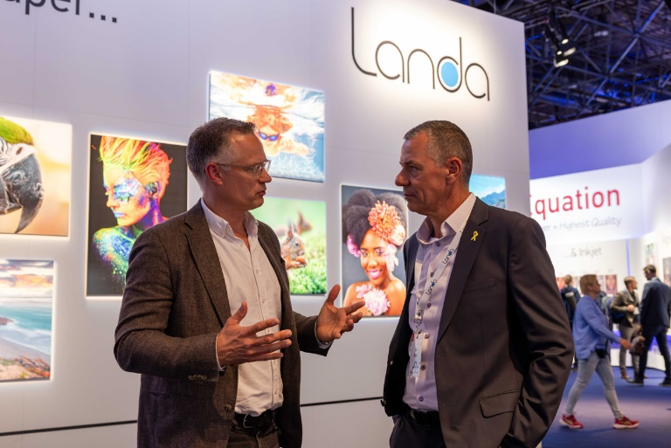
Landa and Gelato Collaboration Announcement - Henrik Müller, Gelato (left) with Gil Oron, Landa (right)

Editors Notes
Join us at Drupa 2024 to experience the power of this collaboration firsthand!
- Landa Digital Printing: Hall 9 / A33-1 – A33-9
- Gelato: Hall 9A / A06

About Gelato
Gelato enables local, on-demand production on a global scale through the world’s largest network for production on demand. Gelato produces personalized products in 32 countries, allowing creators and ecommerce sellers to scale their businesses and reach customers faster while reducing waste, costs, and carbon emissions. In tandem, Gelato leverages the same network to connect the world’s print producers, allowing them to produce, manage, and ship products on a single, more efficient platform, GelatoConnect. By doing so, Gelato is changing the game for creators, makers, people, and the planet.
Gelato was founded by CEO, Henrik Müller-Hansen, in 2007 and consists of the Gelato platform and the consumer brand Optimalprint. Headquartered in Oslo, Norway, the company has offices in Atlanta, Barcelona, Berlin, Boston, Denver, Kyiv, Lahore, London, Madrid, Mumbai, Nashville, Singapore, Stockholm, and Tallinn. To learn more about Gelato, visit Gelato.com. For career opportunities, visit Gelato’s careers page.
About Landa Digital Printing
Landa Digital Printing was founded by Benny Landa with the purpose of liberating printers from the barriers inherent to traditional digital and conventional analog printing. Thanks to Landa’s unique Nanography® technology, Landa Nanographic Printing® Presses produce stunning images of extensive color range, designed to print at any run length, on coated or uncoated media, and in fast turnaround times. www.landanano.com
Gelato Contacts
Danielle Eldredge, Head of PR
+1.904.477.9182
danielle.eldredge@gelato.com
Landa Contacts
EMEA & China:
Ben Dodson
Incus
Tel: +44 1737 294001
ben.dodson@incus-media.com
Americas:
Helene Cohen Smith
HSPR
Tel: +1 321 388 6511
smith@helenesmith.com

